Joint analysis of frontal theta synchrony and white matter
following mild traumatic brain injury

James F. Cavanagh, Rebecca E. Rieger, J. Kevin Wilson,
Darbi Gill, Lynne Fullerton, Emma Brandt, Andrew R. Mayer

SUPPLEMENTAL MATERIALS

Charts Observed
mTBI Eligible (n=7663)

Detail Screened
mTBI Eligible (n=1408)

Called
mTBI Eligible (n=1182)

Forwarded to Study Coordinator
mTBI Eligible (n=250)

Screened for Study
mTBI Eligible (n=162)

Met Criteria & Invited
mTBI Eligible (n=81)

Arrived to Session 1 & Consented
mTBI Eligible (n=60)

Supplemental Figure 1. Flow diagram of the recruitment pipeline. An Emergency Department faculty reviewed charts to identify individuals who had recently visited the Emergency Room for an acute TBI. If the participant met initial criteria, they were called to see if they would be interested in participating in the study. The study coordinator performed a more in-depth screening and invited eligible people to participate in the study.

S1 Enrollment
Ctl Consented (n=33)
Eligible (n=32)
mTBI Consented (n=60)
Excluded after consent (n=1)
- Revealed prior brain injury (n=1)

Excluded after consent (n=8)
- Revealed prior brain injury (n=1)
- Revealed no LOC (n=2)
- Declined to participate after consent (n=2)
- All assessments done >14 days (n=3)

Eligible (n=52)
MRI (n=30)
- MRI ineligible (n=1)
- Bad Data (n=1)

MRI (n=45)
- MRI ineligible (n=4)
- MRI not available (n=1)
- Claustrophobic (n=2)

MRI

DPX Beh (n=29)
- Bad beh (n=3)

DPX Beh (n=44)
- Bad beh (n=8)

Behavior

DPX EEG (n=26)
- No EEG: Big Hair (n=1)
- Bad EEG (n=2)

DPX EEG (n=42)
- No EEG: Big Hair (n=1)
- No EEG: Too Injured (n=1)

EEG

Data Fusion
MRI & EEG (n=36)

MRI & EEG (n=25)

Supplemental Figure 2. Flow diagram of the first session detailing reasons for attrition for varied assessments. Some participants revealed additional detail that conflicted with their self-report in the initial phone interview (no loss of consciousness, prior brain injury) and others were unable to complete all assessments within the 14-day post-injury cutoff. EEG was only analyzed in individuals who performed above 25% accuracy on the bX probe condition.

Session 1
CTL Eligible (n=32)
mTBI Eligible (n=52)

Session 2
Session 2 eligible (n=31)
- Session 2 lost to attrition (n=1)
- Unable to contact (n=1)

Beh (DPX n=30)
- Bad beh (n=1)

EEG (DPX n=25)
- No EEG: Big Hair (n=1)
- Bad EEG (n=1)
- Low trl ct (n=4)

Session 2 eligible (n=41)
- Session 2 lost to attrition (n=11)
- Unable to contact (n=9)
- Unable to schedule (n=2)

Beh (DPX n=37)
- Bad beh (n=4)

EEG (DPX n=34)
- No EEG: Big Hair (n=1)
- Bad EEG (n=3)
- Low trl ct (n=3)
- Bad Beh (n=4)

Session 3 eligible (n=27)
- Session 3 lost to attrition (n=4)
- Unable to contact (n=4)

Beh (DPX n=25)
- No Beh: only phone interview (n=1)
- Bad beh (n=1)

EEG (DPX n=25)
- No EEG: only phone interview (n=1)
- Bad beh (n=1)

Session 3
Session 3 eligible (n=30)
- Session 3 lost to attrition (n=11)
- Unable to contact (n=9)
- Unable to schedule (n=2)
- Intervening injury (n=1)
- Session 3 addition (n=1)
- Missed S2 but came to S3

Beh (DPX n=27)
- Bad beh (n=3)

EEG (DPX n=23)
- No EEG: Big Hair (n=1)
- Bad EEG (n=1)
- Low trl ct (n=2)
- Bad beh (n=3)

Supplemental Figure 3. Flow diagram of the second and third sessions detailing reasons for attrition for varied assessments.

Supplemental Table 1. Main and interaction effects from mixed linear models for other measures of DPX task performance. BSI indicates the Behavioral Shift Index (aY-bX / (aY+bX)). In the Cronbach’s alpha columns, ‘X’ indicates an average negative covariance between items, making ICC impossible to compute. The bX condition alone is also shown here, which had stronger effect sizes than the bX-aY contrasts shown in Table 3 but smaller effect sizes than the general RT or accuracy contrasts, again suggesting that any behavioral deficits in mTBI are more generic across conditions than specific to any task condition.

 | Main Effect of Group | Group * Session Interaction | CTL  alpha | mTBI  alpha
DPX: BSI RT | F(1,82.52)=0.28, p=.60 | F(2,120.49)=0.20, p=.82 | .14 | .05
DPX: BSI Acc | F(1,76.57)=3.24, p=.08 | F(2,114.54)=0.10, p=.91 | X | X
DPX: bX RT | F(1,75.46)=4.93, p=.03 | F(2,111.52)=1.87, p=.16 | .62 | .81
DPX: bX Acc | F(1,73.45)=2.69, p=.11 | F(2,109.34)=2.19, p=.12 | .72 | .88

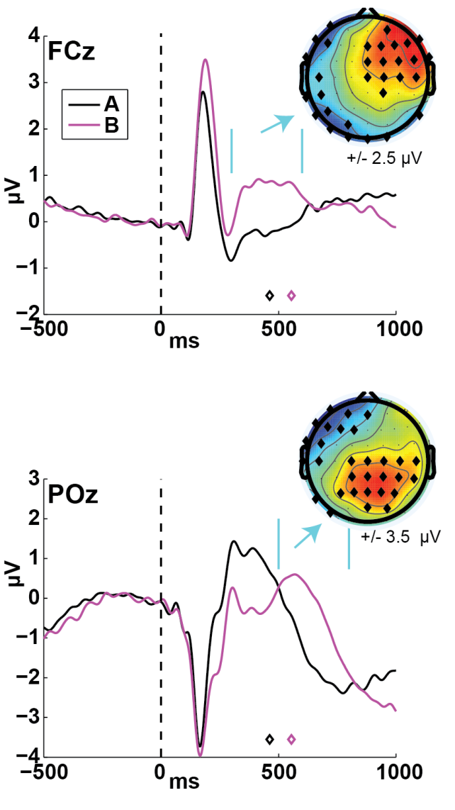

Supplemental Figure 4. Event-related potentials to the A and B cues, collapsed across all participants and sessions. Data were filtered between .1 and 20 Hz and baseline corrected to the average activity from -200 to 0 ms pre-feedback. Black and magenta diamonds show the mean RT for each condition. Topographic plots show the mean amplitudes in the time window indicated by vertical cyan bars. Diamonds on the topographical plots indicate statistically significant differences (B vs. A uncorrected).

Supplemental Figure 5. Medio-lateral ISPC collapsed across all participants and sessions, split by hemisphere. Topographic plots are averages over the temporal ROI (400 to 700 ms), magenta diamonds show the electrodes selected for their time-series representation. For proactive control (as detailed in the main text), electrodes F5 and F6 are plotted. For reactive control (probe-locked aY condition minus aX condition), F6 did not show an enhanced response to reactive control, so the timeseries is plotted from AF8. Overall, reactive control ISPC was larger on the right than the left side, and was about 2-3 times larger than proactive control ISPC. However, this comparison reveals considerable uncertainty in spatial and temporal variance for hemispheric effects even within the ROI, suggesting potential influence of other variables on medio-lateral theta band phase synchronous instantiation for the implementation of control.

Supplemental Figure 6. ISPC effects were similar at a different electrode pair (F7 & F8) and did not have an aberrant value in the Control group session 3, however statistical effects were overall weaker in this a posteriori pair. Main effect of group: F(1,122.25)=2.34, p=.127; Group * Hemisphere: F(1,141.30)=2.15, p=.145; Group * Session: F<1; Group*Hemisphere*Session: F<1.

Supplemental Figure 7. Function-phenotype relationships, split by hemisphere. Session 1 theta band phase synchrony (ISPC) predicts recovery from executive deficits (FrSBe) in the mTBI group between the first and second sessions. This relationship was strongest on the left (FCz-F5: bottom), but the right (FCz-F6: top) also contributed to the combined pattern reported in Figure 5.

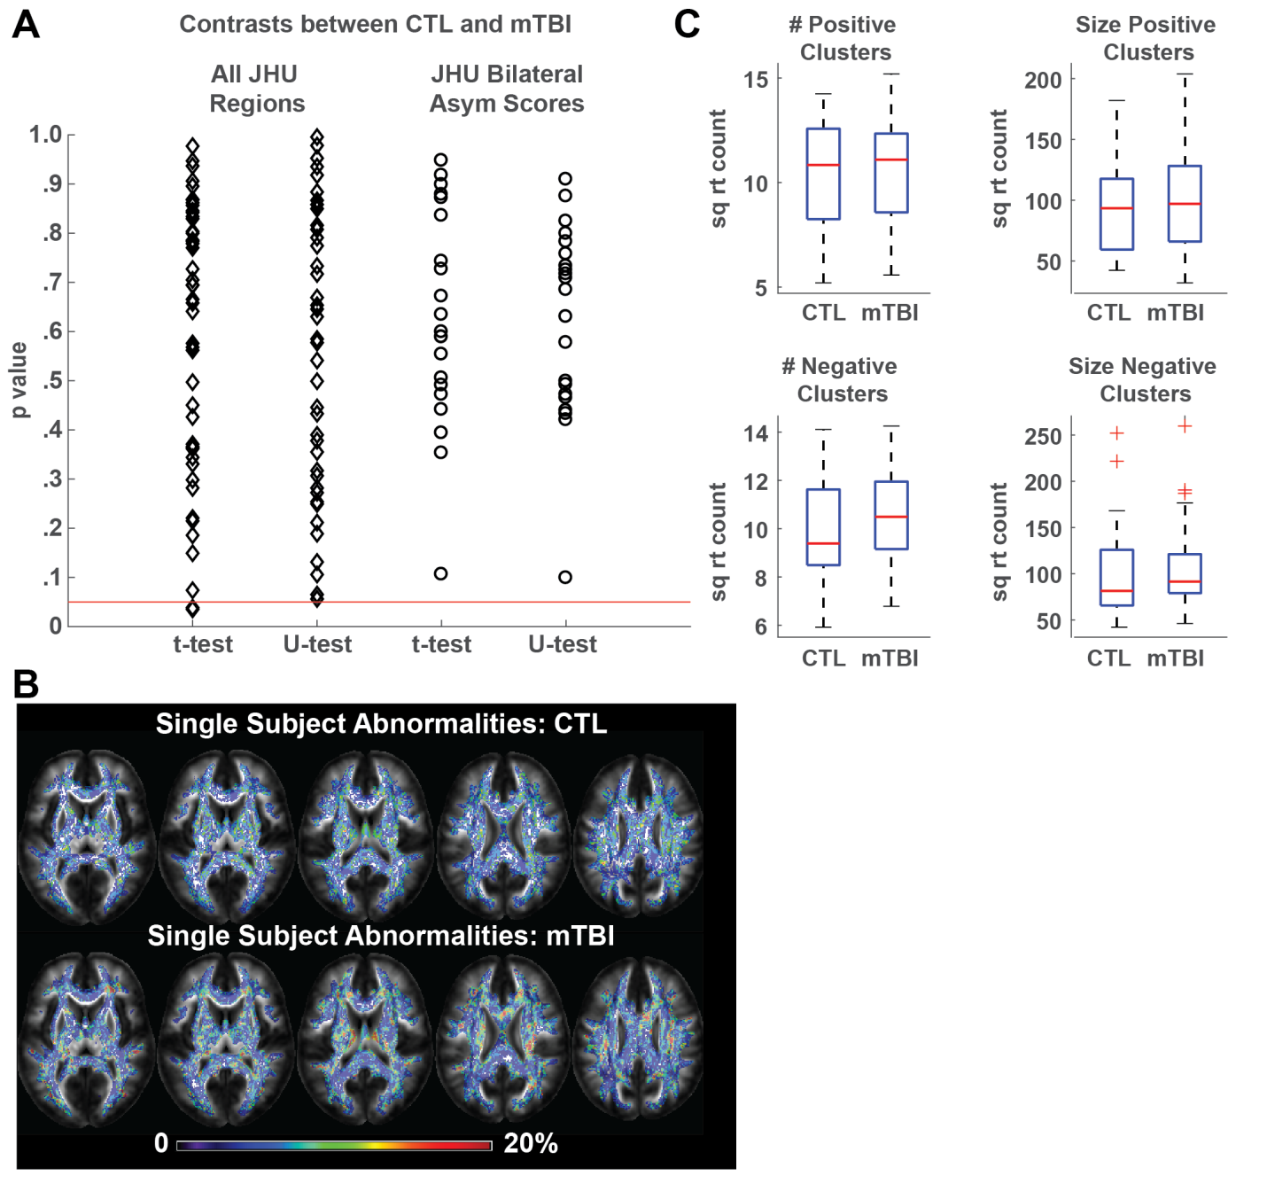
Supplemental Figure 8. Fractional anisotropy alone did not distinguish groups. A) p-values from all JHU region pair-wise contrasts (parametric and non-parametric) between CTL and sub-acute mTBI groups. There were only 2 parametric tests that were below the p<.05 level of statistical significance (none for non-parametric), which is exactly the amount expected by chance (5%). Also shown are asymmetry scores from all bilateral JHU regions (right-left / right+left); none of these were significantly different between groups. B) Axial views of single-subject abnormality distributions. C) Distribution of subject-specific abnormalities: number and size of positive and negative clusters for each group. There were no significant differences between groups on any of these measures from parametric or non-parametric tests.

Supplemental Figure 9. All 8 Independent Components for Inter-site Phase Consistency measures from the jICA. Vertical magenta bars identify the temporal ROI shown in Figure 4. IC #4 captured this window most effectively, and only this IC was significant different between groups.

Supplemental Figure 10. Although TOPF differed between groups, it did not relate to ISPC or change in FrSBe score.

Supplemental Figure 11. ISPC effects were not observed at a control posterior site equidistant from FCz (CP3 and CP4), demonstrating the frontal specificity of these effects. Main effect of group: F(1,113.11)=0.232, p=.631; Group * Hemisphere: F(1,149.74)=1.40, p=.238; Group * Session: F(2,258.69)=2.576, p=.078; Group*Hemisphere*Session: F(4,241.59)=0.62, p=.65.

